**2. Overall Description**

**2.1 Product Perspective**

The system acts as a middle man between users and third parties by collecting data from registered users and forwarding requested data to third parties with due permission or anonymized. As added services, the system provides services for elderly people and marathon organizers. Elderly people can make use of a non-intrusive automated sos service by entering their health parameters which will be monitored by the system and ambulance will be made available when the values reach below threshold. Run organizers can make use of the system to setup run path and participants can enroll for the same. A spectator view is also provided with participant’s position on map.

The entities involved in the system is described with the help of a class diagram and the various control flows are described using an activity diagram

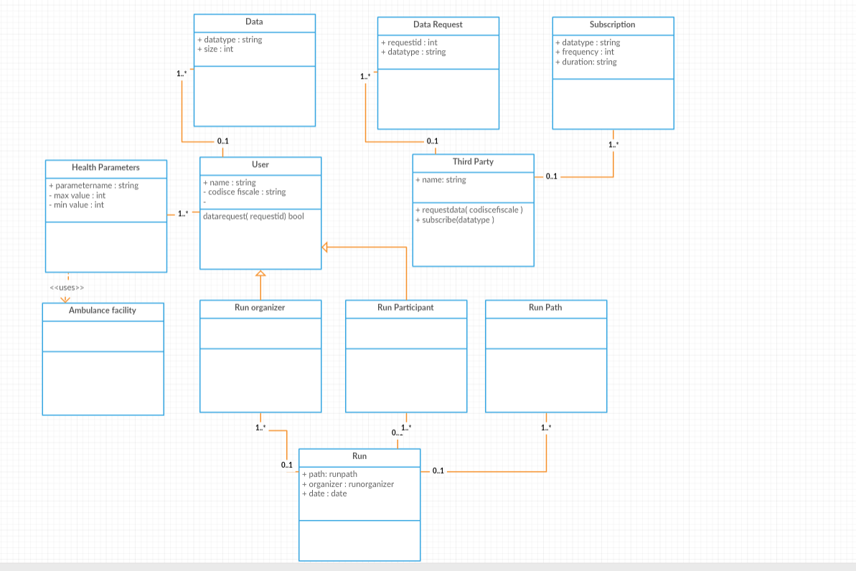

Figure 1 – Class Diagram

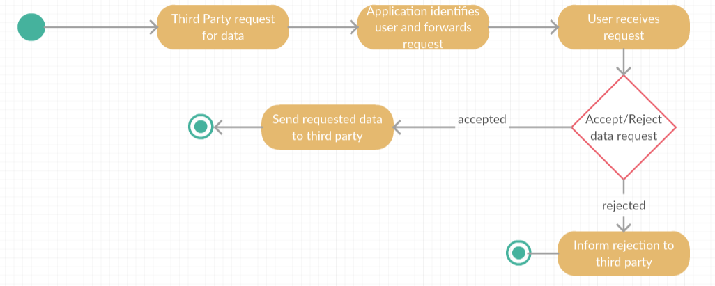

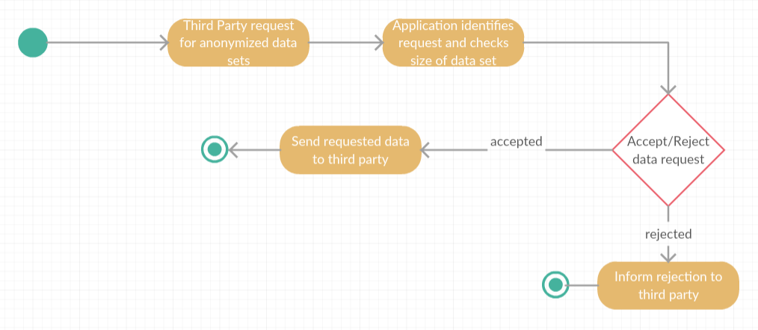

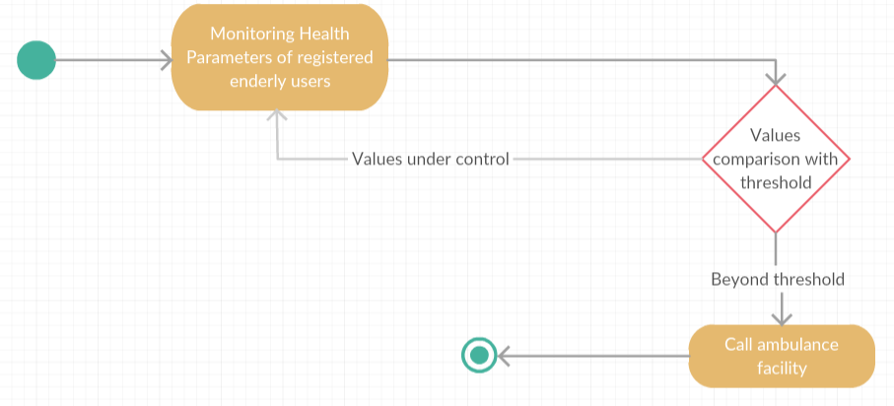

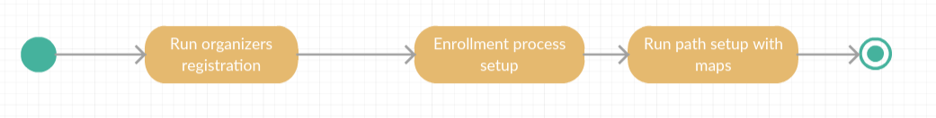

Figure 2 – Activity Diagram for all users

**2.2 Product Functions**

**2.2.1 Data as a service**

The main goal of this function is to collect data from registered users and make it available for third parties on request with due permission from the user. The app users and third parties need to register with the app via the registration portal to avail this service. Every time a third party requests for data from a specific individual, the request is forwarded to the user to confirm and the data is made available to the third party only when the user accepts the request.

**2.2.2 Data set collection**

This function allows the third party to request for anonymized data of group of individuals. These requests are handled by the app itself and the decision is based on the size of the data set requested in order to preserve anonymity. This requires the system to be able to process and retrieve data based on a set of given conditions. Moreover, as an added service, the third party can also subscribe to new data and the app will send it over as soon as they are available.

**2.2.3 Automated SOS**

As a value-added service for the user, the app provides a personalized and non‐intrusive SOS service to elderly people. It collects health condition related threshold details from registered elderly users and monitors them continuously. In case the parameters go below threshold, an ambulance will be made available to the user’s location in less than 5 seconds of reaction time. The app makes use of an existing ambulance facility for the same.

**2.2.4 Track for run**

This function helps run organizers to set up a path for a run. They can also setup an enrollment process using which the users who are willing to participate can register for the run. A map view of the run with positions of participants on the path will also be made available for run spectators to watch.

**2.3 User characteristics**

Basic User – A person who is registered to the app and allows his data to be collected which will be made available to third parties upon request.

Third party – Registered users who request for data from specific individuals or group of individuals using the app including subscribing for new data.

Elderly people – Registered users who subscribe for an automated SOS service by entering personal health conditions and threshold parameters.

Run organizers – Registered users who can set up a path for a run and get participants registered through an enrollment process.

Run participants – Registered users who can enroll for a run

Run spectators – Users who make use of the spectator service of the app that gives a map view of the run with the position of the participants in the run.

**2.4 Assumptions, dependencies and constraints**

**2.4.1 Domain assumptions**

D1: Users have valid codice fiscale

D2: Location of users is obtained from GPS of the user's device

D3: Users all always connected to internet

D4: Third party knows the codice fiscale of the user

D5: Facility to call an ambulance is available

D6: System uses existing map application

D7: Run participants should be registered users of Data4Help service

D8: Spectators have internet access

**2.4.1 Constraints**

C1: Size of data set requested for anonymized data is larger than 1000

C2: People aged above 50 are considered as elderly people

C3: Reaction time to call the ambulance facility is less than 5 seconds

2.4.3 Dependencies

The system is dependent on few external services in order to reuse existing infrastructure.

1. Ambulance facility – An existing ambulance calling facility that would allocate an ambulance to provided location based on proximity and availability.
2. Map – An existing map service that would be helpful for setting up a path for the run and show the participants on the map with their location data.

(GPS, WEARBLE DEVICE)